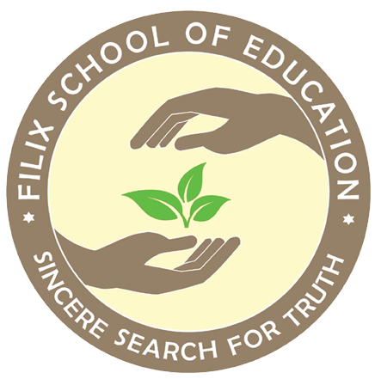

Filix School of Education
Book List [2025-26]
Grade II

Subject | Name of Books
English | - Mridang 2 [NCERT]  - Sparkle 2A and 2B Nanritam [Subject Enrichment]  - Getting Granny’s Glasses Ruskin Bond Puffin [Subject Enrichment]  - The Enormous Crocodile by Roald Dahl Puffin [Subject Enrichment]
Mathematics | - Joyful Mathematics II [NCERT]  - Journey Through Numbers 2A and 2B Nanritam [Subject Enrichment]
Bengali [Second Language] | - Sahaj Path 2 Chhaya Prakashani  2. Aamra Pori Aamra Likhi 2 Shishu Sahitya Sansad  3. Chhotoder Ramayan
Hindi [Second Language] | - Sarangi 2 [NCERT]  - The Learning Bridge Hindi Pathmala 2 Bhag 2 Onelern [Subject Enrichment]  - Meri Sulekh Mala 2 Golden Circle [Subject Enrichment]
Computer Science | - Code to AI 2 Avartan

